History/Geography
Superheroes travel to many countries. Use a map to make a list of countries they’ve flown to!

Maths
Check your superpowers. Throw a ball as far as you can. How far did you manage to throw it? Measure it in steps, then use a tape measure.
Superhero lift off! Write numbers backwards from 100!
PE
Copy the superhero dance! Can you create your own? https://www.youtube.com/watch?v=Py4fhsx3Ct4

Phonics
Use your Phonics’ Phase booklet to keep your knowledge as quick as a flash! Don’t forget those alien words!

RE
How might people see Jesus as a superhero? Write a list of his superpowers.

Art/DT
Design your own superhero outfit, annotating the reasons behind your choices!
Build a superhero belt or shield out of card board. What super power does it give you when you wear it?
Create some superhero puppets! Can you sew them or neatly cut some out? Make a show!
Science
Superheroes shine bright! How many different materials you have in your house? Collect them together and group them. Which are shiny? Which are smooth? Which are heavy? Write a list in a table or a Venn diagram.
Superheroes are very strong – their hearts must work very hard to keep the blood pumping around the body! Create some exercises other people can use to keep their bodies fit, strong and healthy!
Write a food diary for a superhero.

Home Learning Y1/2 Theme: 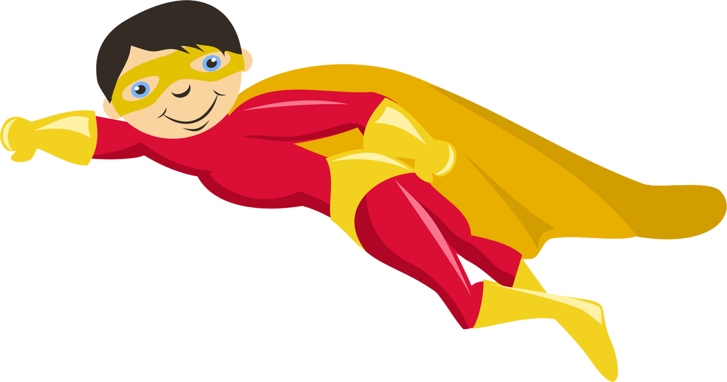
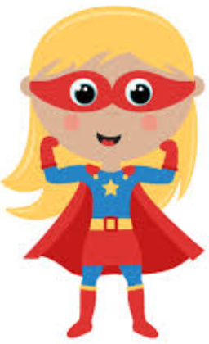Superheroes!
English
Letter writing
Write a letter to someone in your local area who has been a superhero! Do you know any nurses, doctors, teachers or carers? Thank them personally for their hard work during this time.
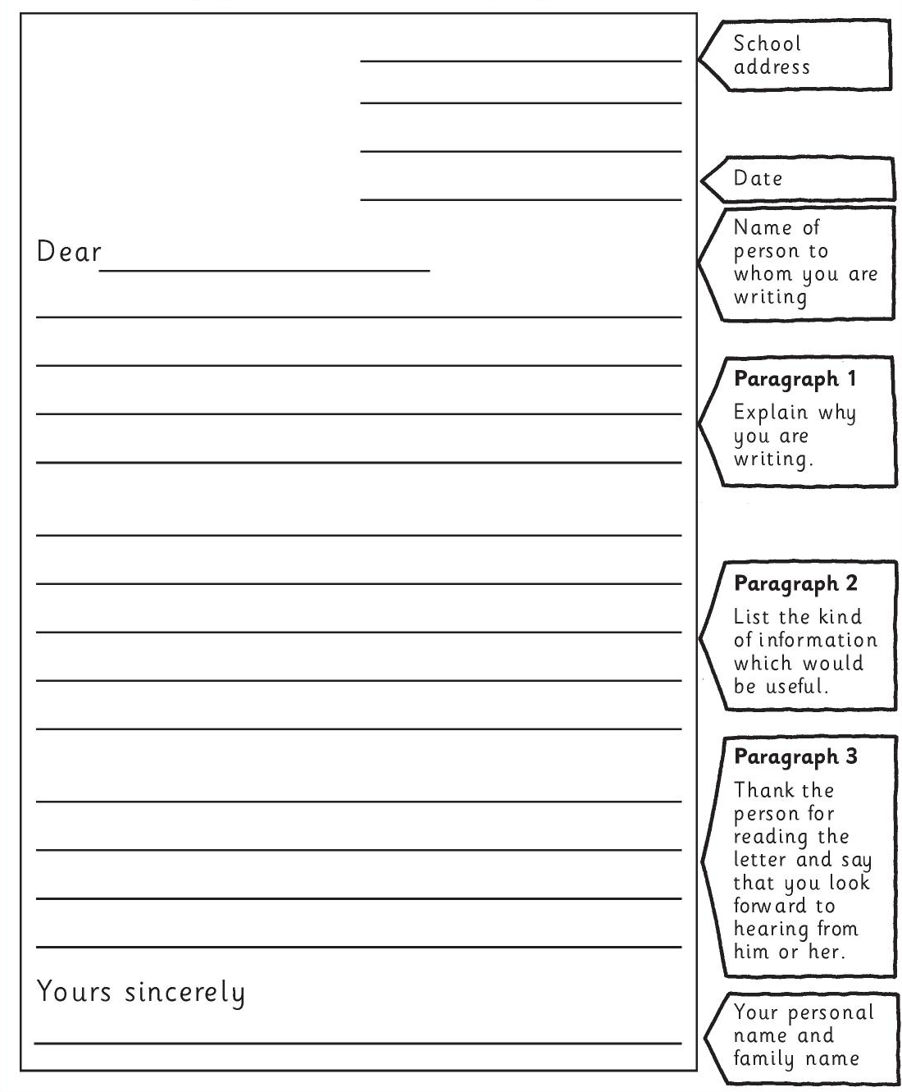

Key Vocabulary

Create a glossary of words that you have used across all of the different learning tasks. A glossary is a list of words in alphabetical order with definitions.

