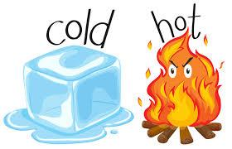
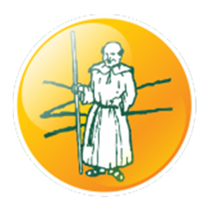
Key Vocabulary
Create a glossary of words that you have used across all of the different learning tasks. A glossary is a list of words in alphabetical order with definitions.
Add this to the glossary you have been making each week.
PE
Teach your parents to play the game ‘The Floor is Lava’! When this statement is called out you have to climb on something so that you are not touching the floor. Try not to get burnt!!!
Maths
When it is hot or cold the temperature changes. Could you record the temperature for the week and record it in a table? If you have a thermometer it’s great for reading scales.

Measure out 500ml of hot water and 500ml of cold water. How do they change overnight? Read the scale to check and record the changes you can see.
Home Learning Theme:
Hot and Cold!
Geography
Where are the hottest and coldest parts of the world? Make a table to list some hot and some cold countries. What would you need to pack if you were going to visit these places. Use the template to pack your suitcase.
History
Over the years our planet has changed a lot because of Climate Change. Look at the powerpoint all about climate change and discuss the different changes that have happened. Use the hand template to write 5 promises you will make to help protect our planet for future generations.
RE
Throughout the year we have 4 seasons which give us hot and cold weather. Write a prayer about the things you appreciate about the seasons. Think about the different temperatures and what these bring to the world.
Phonics
Use your Phonics’ Phase booklet to keep your knowledge hot, hot, hot!! Don’t forget those alien words!
English
Book of the Week!
Our books of the week are going to be:
Lost and Found by Oliver Jeffers and
Meerkat Mail by Emily Gravett
Look out for your virtual learning link to join in with our book talk this week!
Could you write a descriptive piece of writing to explain all of the things you can see, hear, smell when it’s hot? Maybe you could do it again, thinking about how you feel when it’s cold. How do your feelings compare? Use the senses plan to help you map out your words.
Write and record a weather forecast that you have created for next week, explaining how the weather and temperature have changed over the week.
Science
Animals live in different habitats. Sort the animals based on the climate they live in. Then choose one and research it more - create a fact file / poster with all your findings.
In this hot weather, you must have used ice to cool down your drinks. Why not experiment to see what will melt ice the quickest. Let us know which one wins!
Art/DT
Volcanoes are very very hot places! Have a go at making your own out of papier mache and then see if you can make it erupt!
Build your own igloo! Smaller ones can be made from sugar cubes but if you have building blocks at home, try to make one that you can fit inside! Send us a picture to the home learning email.

