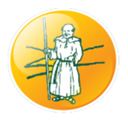
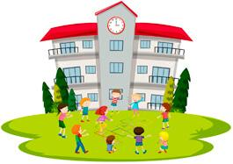
PE
Design some new games that your friends could play when you go into the next year group. What were the best games you played this year in the playground?
Maths
This year has been a very strange year. How many weeks have you now been out of school? Take a look at a calendar and see if you can count how many weeks we’ve been out. Add on the weeks of the summer holidays. How many now?
How many children are in your class? Count out that many counters and see how many different ways you can group them!
Home Learning Theme:
Our Year Book!
Geography
Monks Risborough school is very special because there are lots of green outdoor areas. Look at the aerial view map of the school. How would you improve it to make it better? What learning experiences could you design? Edit the map to make our school even more incredible!
History
Monks Risborough Primary school was first built in 1858. This was during the Victorian period of time. Look at the PowerPoint to find out about Victorian schools. Would you like school then? Why? Why not? Complete the challenge sheet or maybe set up your home learning experience to be Victorian for the day!
RE
In different religions there are different religious leaders. In our school we also have different leaders who guide us and support us. Who are the leaders in school who you are inspired by? Draw a picture of them and write why you feel inspired by them!
Phonics
Use your Phonics’ Phase booklet to keep your knowledge fresh for your next year! Don’t forget those alien words!
English
Book of the Week!
Our books of the week is going to be:
One Year with Kipper by Mark Inkpen
https://www.youtube.com/watch?v=21XL0ZVqvgk
This task is going to require your memory! Think about all topics you learned when you were at school. Create a booklet with a page for each topic, explaining what next year’s children have got to look forward to!
Write a letter to your teacher next year. Tell them a little bit about you, what your favourite things are, what challenges you have faced being in your current year and what you would like to improve on for the next year. They would love to know all about you!
Science
NATURE COLLECTION!
Challenge children to explore outside and assemble a collection of natural objects in their boxes: sticks of different lengths and sizes; leaves of different colours and shapes; stones with different surfaces. What to do with the collection:
• Identify ways in which the natural resources are similar and different
• Group and classify them according to observable features
• Identify the leaves with this Nature Detectives’ leaf identification tool
• Discuss which objects are alive, were once alive or have never been alive, and encourage the children to give reasons for their ideas
• Create a model animal inside their box from some or all of their natural resources. Stories such as Leaf Man by Lois Ehlert or Fletcher and the Falling Leaves by Julia Rawlinson could provide inspiration for this
Resources per child • Cardboard box • Leaf identification tool Science explored • Living things • Plants • Identifying and classifying Interesting links • Nature Detectives Leaf Dial • Science Fun at Home - Scavenger
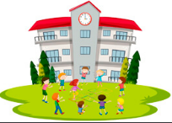

Key Vocabulary
Create a glossary of words that you have used across all of the different learning tasks. A glossary is a list of words in alphabetical order with definitions.
Add this to the glossary you have been making each week.
Art/DT
Design and create a yearbook for the Wrens class or Kites class with all of your class members. Use your best portrait skills to draw a picture of each of them with their names underneath. You might even print some pictures you already have! See if, with help from an adult, you can sew your book together.

