Name: Date:
Knights’ Maze 1
The knight is searching for the king. Draw the path for the knight starting at 3 and counting in 3s up to 300. | The squire must deliver the sword to the knight. Draw the maze's path to the knight starting at 4 and counting in 4s up to 400.
  189 | 192 | 213 | 216 |  | 219 | 294 | 297 | 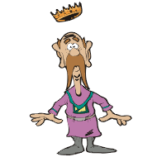
  186 | 195 | 210 | 207 |  | 222 | 291 | 300
  183 | 198 | 201 | 204 |  | 225 | 288
  180 | 177 | 234 | 231 |  | 228 | 285 | 282 | 279 | 276 | 273
  171 | 174 | 237 | 240 |  | 243 | 246 | 249 | 258 | 261 | 270
  168 | 165 | 162 | 159 |  | 120 | 117 | 252 | 255 | 264 | 267
  147 | 150 | 153 | 156 |  | 123 | 114 | 111 | 108 | 105 | 102
  144 | 135 | 132 | 129 |  | 126 | 57 | 60 | 63 | 96 | 99
  141 | 138 |  | 18 |  | 21 | 54 | 51 | 66 | 93 | 90
  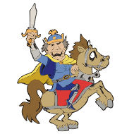 |  |  |  | 15 | 24 | 27 | 48 | 69 | 72 | 87
   |  |  |  | 12 | 9 | 30 | 45 | 42 | 75 | 84
   |  |  |  | 3 | 6 | 33 | 36 | 39 | 78 | 81
  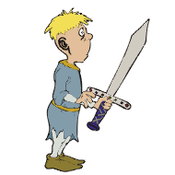 |  |  | 4 | 8 | 12 | 96 | 100 | 104
   |  |  | 40 | 36 | 16 | 92 | 88 | 108 | 112
   |  |  | 44 | 32 | 20 | 80 | 84 | 120 | 116
  196 | 192 | 188 | 48 | 28 | 24 | 76 | 72 | 124 | 128
  200 | 204 | 184 | 52 | 56 | 60 | 64 | 68 | 136 | 132
  212 | 208 | 180 | 176 | 172 | 168 | 164 | 160 | 140 | 144
  216 | 220 | 224 | 356 | 360 | 364 | 368 | 156 | 152 | 148
  252 | 248 | 228 | 352 | 348 | 344 | 372 | 384 | 388 | 392
  256 | 244 | 232 | 332 | 336 | 340 | 376 | 380 | 400 | 396
  260 | 240 | 236 | 328 | 324 | 312 | 308 | 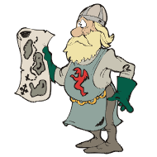
  264 | 268 | 280 | 284 | 320 | 316 | 304
   | 272 | 276 | 288 | 292 | 296 | 300

Name: Date:
Knights’ Maze 2
The knight is looking for the princess. Draw the path for the knight starting at 6 and counting in 6s up to 600. | The knight is looking for the princess. Draw the path through the maze for the knight, starting at 7 and counting in 7s up to 700.
  528 | 534 | 552 | 558 | 576 | 582 | 600 | 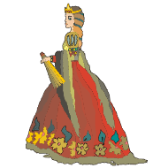
  522 | 540 | 546 | 564 | 570 | 588 | 594
  516 | 498 | 492 | 488 | 480 | 474
  510 | 504 | 90 | 96 | 462 | 468 | 426 | 420 | 402 | 396
  72 | 78 | 84 | 102 | 456 | 438 | 432 | 414 | 408 | 390
  66 | 60 | 54 | 108 | 450 | 444 | 174 | 180 | 378 | 384
  24 | 30 | 48 | 114 | 156 | 162 | 168 | 186 | 372 | 366
  18 | 36 | 42 | 120 | 150 | 144 | 198 | 192 | 354 | 360
  12 | 6 |  | 126 | 132 | 138 | 204 | 210 | 348 | 342
  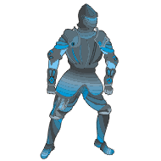 |  |  | 240 | 234 | 228 | 222 | 216 | 330 | 336
   |  |  | 246 | 264 | 270 | 288 | 294 | 324 | 318
   |  |  | 252 | 258 | 276 | 282 | 300 | 306 | 312
  49 | 42 | 21 | 14 | 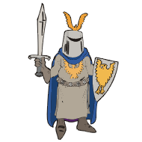 |  |  |  | 455 | 462
  56 | 35 | 28 | 7 |  |  |  | 441 | 448 | 469
  63 | 70 | 133 | 140 |  |  |  | 434 | 427 | 476
  84 | 77 | 126 | 147 | 154 | 371 | 378 | 413 | 420 | 483
  91 | 112 | 119 | 168 | 161 | 364 | 385 | 406 | 497 | 490
  98 | 105 | 182 | 175 | 350 | 357 | 392 | 399 | 504 | 511
  231 | 224 | 189 | 196 | 343 | 574 | 567 | 560 | 553 | 518
  238 | 217 | 210 | 203 | 336 | 581 | 588 | 595 | 546 | 525
  245 | 252 | 315 | 322 | 329 | 700 | 693 | 602 | 539 | 532
  266 | 259 | 308 | 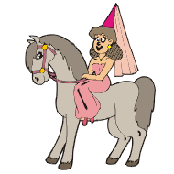 |  |  | 686 | 609 | 630 | 637
  273 | 294 | 301 |  |  |  | 679 | 616 | 623 | 644
  280 | 287 |  |  |  |  | 672 | 665 | 658 | 651

Name: Date:
Knights’ Maze 3
The knight is searching for the king. Draw the path for the knight starting at 8 and counting in 8s up to 800. | The knight must slay the dragon and rescue the princess. Draw the knight's path to the dragon starting at 9 and counting in 9s up to 900.
  512 | 504 | 480 | 472 | 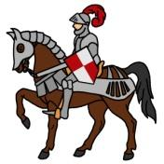 |  |  |  | 64 | 72
  520 | 496 | 488 | 464 |  |  |  | 48 | 56 | 80
  528 | 536 | 448 | 456 |  |  |  | 40 | 32 | 88
  552 | 544 | 440 | 432 | 424 | 416 | 8 | 16 | 24 | 96
  560 | 568 | 576 | 584 | 592 | 408 | 128 | 120 | 112 | 104
  680 | 672 | 616 | 608 | 600 | 400 | 136 | 176 | 184 | 192
  688 | 664 | 624 | 632 | 384 | 392 | 144 | 168 | 208 | 200
  696 | 656 | 648 | 640 | 376 | 368 | 152 | 160 | 216 | 224
  704 | 712 | 784 | 792 | 800 | 360 | 352 | 344 | 336 | 232
  728 | 720 | 776 | 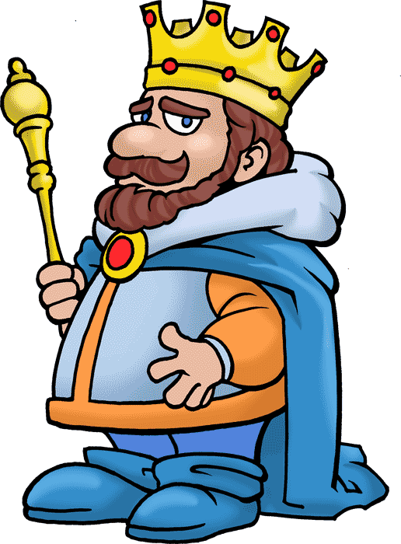 |  |  | 312 | 320 | 328 | 240
  736 | 760 | 768 |  |  |  | 304 | 280 | 272 | 248
  744 | 752 |  |  |  |  | 296 | 288 | 264 | 256
  801 | 810 | 837 | 846 | 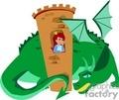 |  |  |  | 513 | 504
  792 | 819 | 828 | 855 |  |  |  | 531 | 522 | 495
  783 | 774 | 765 | 864 |  |  |  | 540 | 549 | 486
  720 | 729 | 756 | 873 | 900 | 585 | 576 | 567 | 558 | 477
  711 | 738 | 747 | 882 | 891 | 594 | 387 | 396 | 459 | 468
  702 | 639 | 630 | 621 | 612 | 603 | 378 | 405 | 450 | 441
  693 | 648 | 657 | 126 | 135 | 144 | 369 | 414 | 423 | 432
  684 | 675 | 666 | 117 | 162 | 153 | 360 | 351 | 324 | 315
  63 | 72 | 99 | 108 | 171 | 180 | 189 | 342 | 333 | 306
  54 | 81 | 90 | 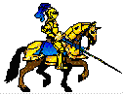 |  |  | 198 | 207 | 216 | 297
  45 | 18 | 9 |  |  |  | 243 | 234 | 225 | 288
  36 | 27 |  |  |  |  | 252 | 261 | 270 | 279

