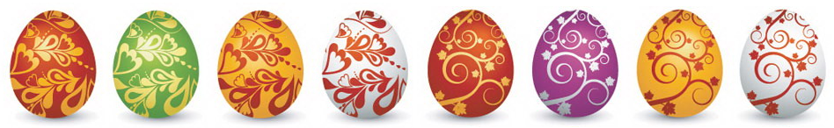

Easter Maths Challenge
ANSWERS
Name: __________________________ Form: ________

ALL working must be shown to gain full marks. You will need a ruler, protractor and a pencil to complete the challenge.

- The Easter Bunny can only carry 3 eggs at once. He has to choose 3 eggs from the following colours: Red, Green or Blue.

How many possible ways can the Easter Bunny carry the eggs?
(He can carry the same colour more than once)

RRR GGG BBB
RRG GGR BBG
RRB GGB BBR
RGB

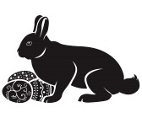

10
________________________________________________________

- At 3 local supermarkets the following deals were on offer for Easter Eggs:
C
A

2 for £3.50
3 for £5
B

4 for £7

If I were to buy 12 Easter Eggs, which supermarket would be cheapest?
A = 4 x £5 = £20
B = 3 x £7 = £21
C = 6 x £3.50 = £21

A
________________________________________________________

- Have a look at the field below:

(2X + 1)m

14m
14(2x+1) = 28x + 14
28x + 14 = 98
28x = 84
X = 3

Area = 98m²
X= 3
14 + 14 = 28
2x + 1 + 2x + 1 = 4x + 2
4 x 3 + 12 = 14
14 + 28 = 42cm
Calculate the perimeter
42cm

________________________________________________________
- A large packet of mini eggs contains 27 eggs. There are 80 children in Y8. How many packets of mini eggs should I buy so that each child gets 2 eggs?

80 children x 2 = 160 eggs

27 x 6 = 162
.:. 6 is the minimum amount

6

_____________________________________________________

The following is a table to do with Easter Eggs:

Type | Weight | Cost per egg | Cost per 100g
Dairy Milk | 175g | £2.00 | £1.15
Flake | 170g | £1.85 | £1.09
Mars | 180g | £1.70 | £0.95
Maltesers | 150g | £1.50 | £1.00
Creme Egg | 160g | £1.55 | £0.97

Complete the table and work out which egg is the cheapest per 100g:
(Tip: Remember to round up with prices)

Mars

______________________________________________________

Use the grid lines to complete the symmetrical pattern:



