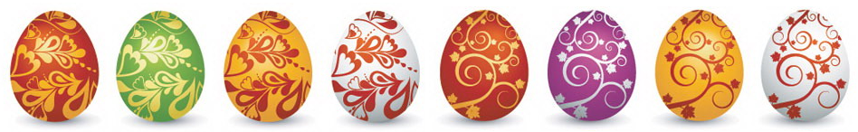

Easter Maths Challenge

Name: __________________________ Form: ________

ALL working must be shown to gain full marks. You will need a ruler, protractor and a pencil to complete the challenge.
.

- The Easter Bunny can only carry 3 eggs at once. He has to choose 3 eggs from the following colours: Red, Green or Blue.

How many possible ways can the Easter Bunny carry the eggs?
(He can carry the same colour more than once)

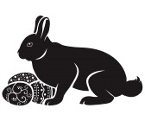

________________________________________________________

- At 3 local supermarkets the following deals were on offer for Easter Eggs:
C
A

2 for £3.50
3 for £5
B

4 for £7

If I were to buy 12 Easter Eggs, which supermarket would be cheapest?

________________________________________________________

- Have a look at the field below:

(2X + 1)m

14m

Area = 98m²
X=

Calculate the perimeter

________________________________________________________

- A large packet of mini eggs contains 27 eggs. There are 80 children in Y8. How many packets of mini eggs should I buy so that each child gets 2 eggs?

_____________________________________________________

- The following is a table to do with Easter Eggs:

Type | Weight | Cost per egg | Cost per 100g
Dairy Milk | 175g | £2.00
Flake | 170g | £1.85
Mars | 180g | £1.70
Maltesers | 150g | £1.50
Creme Egg | 160g | £1.55

Complete the table and work out which egg is the cheapest per 100g:
(Tip: Remember to round up with prices)

______________________________________________________
- Use the grid lines to complete the symmetrical pattern:



