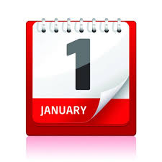
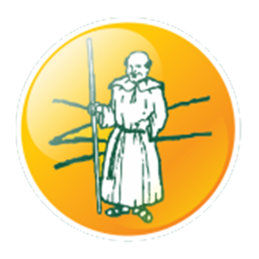
History
Monks Risborough Primary school was first built in 1858. This was during the Victorian period of time. Look at the PowerPoint to find out about Victorian schools. Would you like school then? Why? Why not? Complete the challenge sheet or maybe set up your home learning experience to be Victorian for the day!
RE
Moment of reflection: sit quietly and think about all the wonderful things you’ve learned this year in school and at home and all the opportunities you have been given. Perhaps you might like to write and say a short prayer of thanks. Consider all the teachers you’ve had - both your carers and your teachers at school.
Geography
If you could go on holiday to anywhere in the world, where would you go? Think carefully and then write a description of the place with reasons for your choice. (see sheet)
Art/DT
Draw a picture of each month of this year using the sheet provided. Think about all the things you learned in school and at home. Write a short description/caption for each picture.
PSHE/Mindfulness
Can you create a review of the best bits of your year!
Home Learning Y3/4 Theme:
My Year Book

PE
Think of all the new skills you have learned this year and how you have improved. What would you like to try next year? Can you practise your skills during the summer holidays?

