Measuring Task!
Can you measure yourself and work out how many times bigger than you the different dinosaurs were? If you don’t have a tape measure then estimate your height and then convert it to feet. I suggest you round your height up to the nearest foot, unless you are feeling particularly clever!
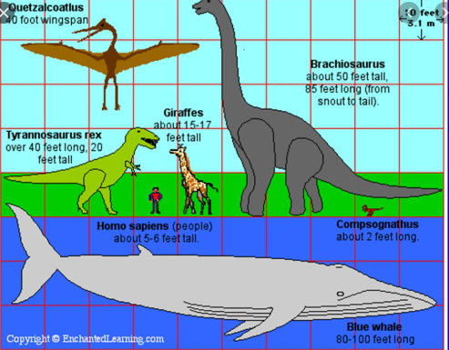
Record all your workings on a separate piece of paper.
Make a table to record your findings:
Dinosaur | Height | How Many Times Bigger than Me!

Quetzalcoatius: 40 foot wingspan
Brachiosaurus: 5o feet tall and 85 feet long (from snout to tail)
Tyrannosaurus Rex: 40 feet long & 20 feet tall
Compsognathus: 2 feet long! (how many time smaller than you was it?)

Can you find the height of 5 or more other dinosaurs and add them to your list?

