Vocabulary | Definition | Picture
Boudicca | The female leader of the Iceni tribe. | 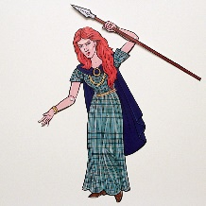
Celts | People living in Britain in tribes, including the Iceni tribe. | 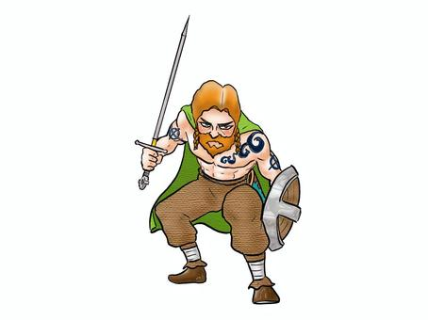
Citizen | A person with all the rights and  protections of a nation or land. | 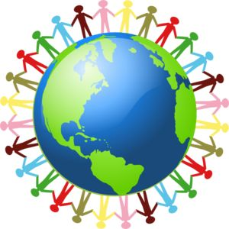
Conquest | Taking control of a place by force, often  with an army. | 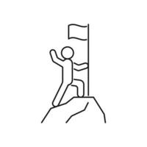
Emperor/  Empress | The ruler of an empire. | 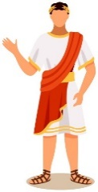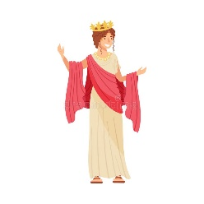
Vocabulary | Definition | Picture
Legion | A large section of the Roman army, made  up of around 5000 soldiers. | 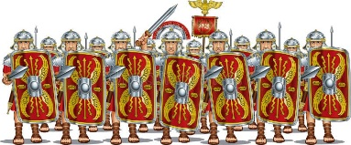
Rebellion | An uprising or revolt by people who want  to challenge what they believe is unfair  treatment by rulers. | 
Roman  Empire | The name used for the land that was  controlled by the Romans, including  large parts of Europe. | 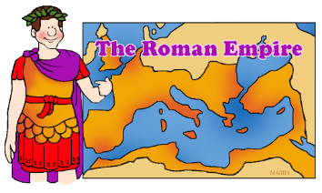
Tribe | A group of people who share the same  culture and values. | 

