History Knowledge Organiser – Year 3 Were the Ancient Greeks respectful?
vocabulary | definition | picture | vocabulary | definition | picture
ancient | Something from a very long time ago. | 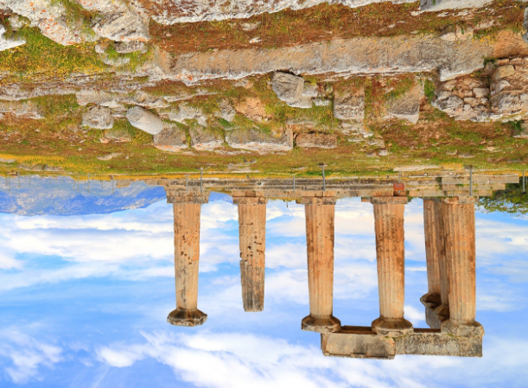 | democracy | A system where citizens of a country or state are involved in the way it is run. | 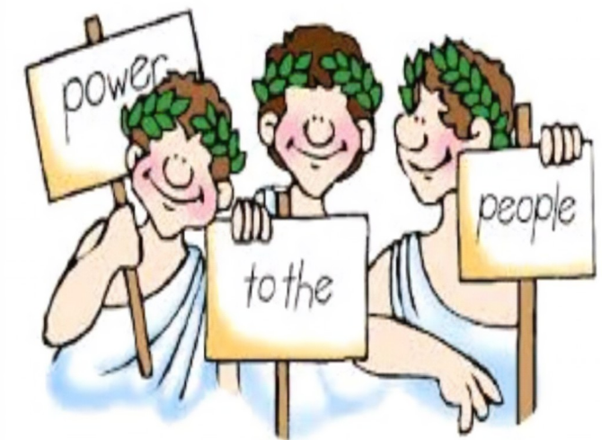
civilisation | A human society with well developed rules | 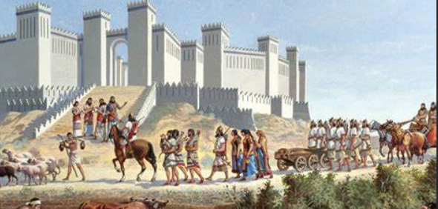 | myth | A story from ancient times about something that has happened long ago that some people believed to be true. | 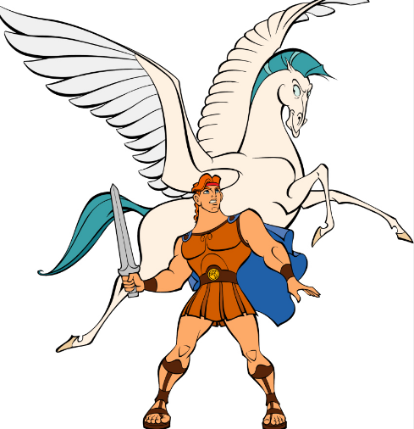
city states | Small areas that ancient Greece was divided into, each with their own government, laws and army. | 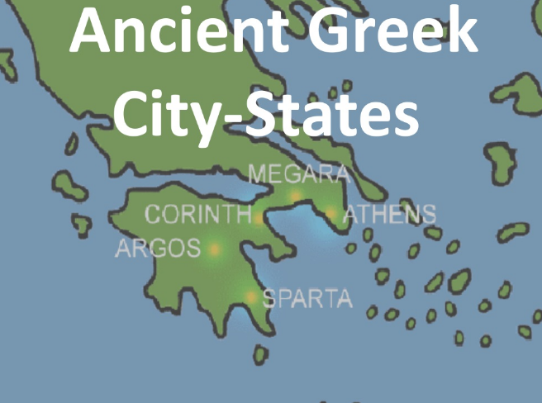 | King Philip II of Macedonia | Independent city states existed for most of the ancient Greek Period. Towards the end of this time King Philip II ruled over all of Ancient Greece. | 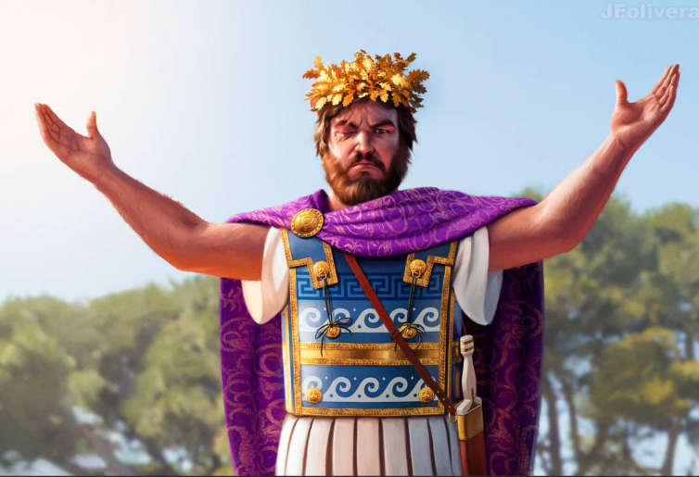
empire | A group of countries or states that are ruled by one ruler or country. | 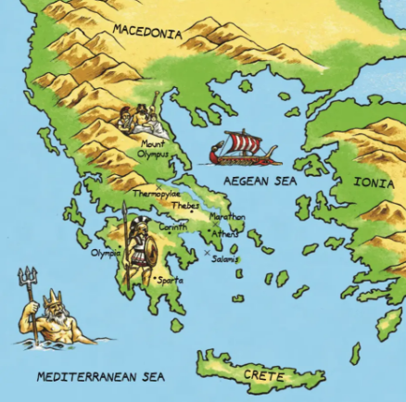 | Alexander the Great | The son of King Philip II, who took over the Greek empire after his father’s death. | 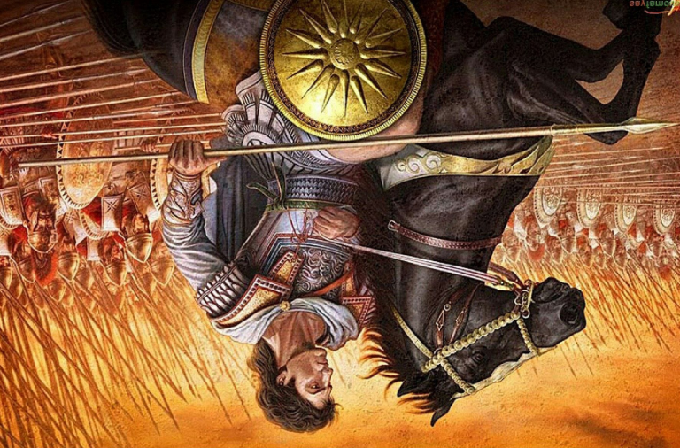
legacies | Things that exist after someone dies or after a civilisation or event has ended. | 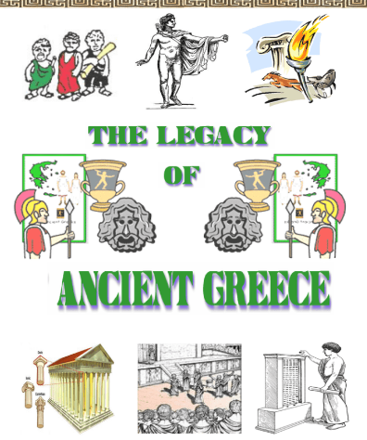 | enslaved | To make someone a slave or a prisoner. | 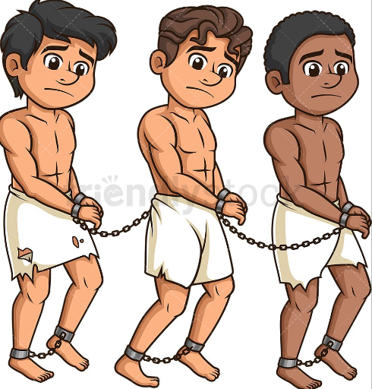
Olympics | First held in ancient Greece in 776 BC. An event organised for men only and including events like boxing and chariot racing. | 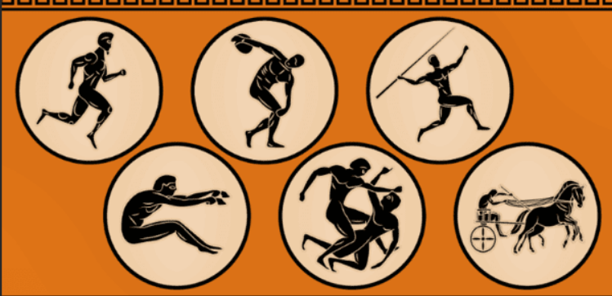 | Greek gods/goddesses | Greeks believed in many different Gods which represented different aspects of human life. | 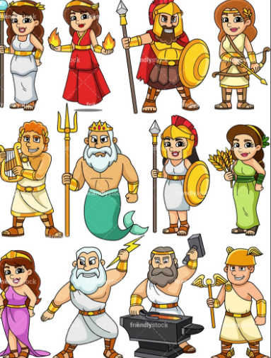
Spartans | Greeks – known for their strong armies and their strength to fight. | 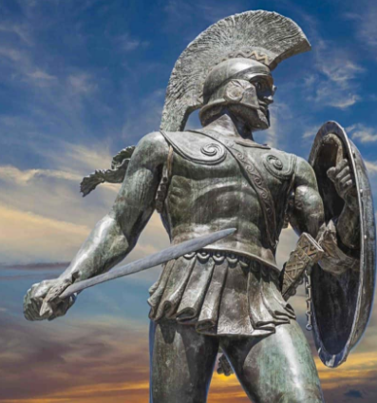 | Mount Olympus | Believed to be where the 12 most powerful Gods lived. | 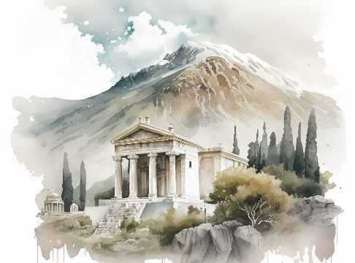
Athenians | Greeks – known for their culture and the development of learning. | 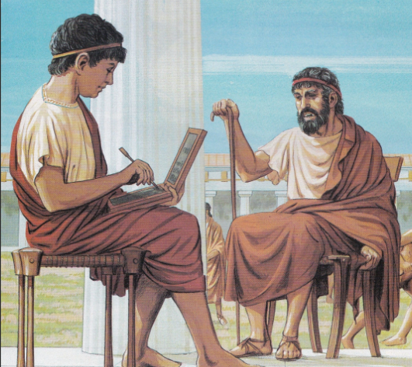 | 

