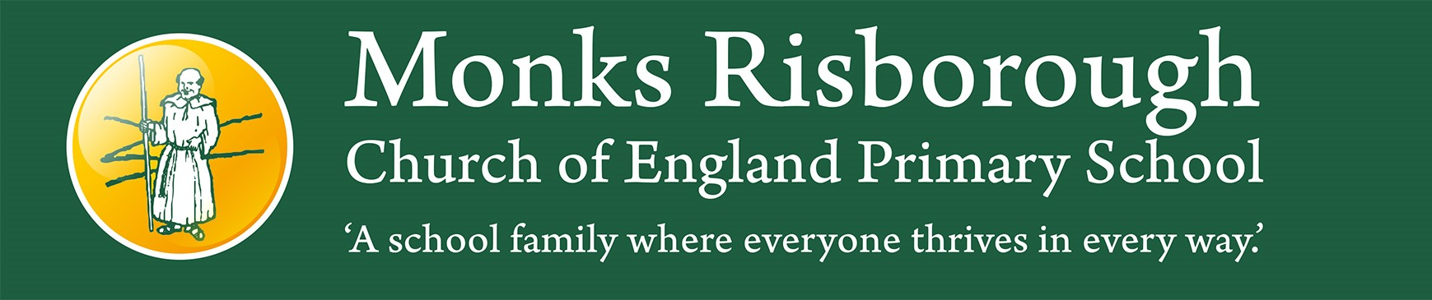

Lunchbox Policy

This policy was adopted Spring 24
The policy is to be reviewed Spring 2027
Signed ………………………………………..Chair of Governors

Overall aim of the policy
To ensure that all packed lunches brought from home and consumed in school (or on school visits) provide pupils with healthy and nutritious food that is similar to food served in schools, which is regulated by national standards.

Why the policy was formulated
At Monks, we believe that healthy and nutritious food are vital to support children to thrive in their learning. The problems associated with a poorly balanced diet are well documented through clear scientific evidence. In the short term, there can be a negative effect on concentration and behaviour but ultimately, in the long term, a poor diet can lead to diseases and conditions that are life threatening.
This policy is aimed at:
• making a positive contribution to children’s health
• encouraging a happier and calmer population of children and young people
• promoting consistency between packed lunches and food provided by schools which must adhere to national school food standards. Please visit School meals - food standards - GOV.UK (www.gov.uk) for more information.
To whom the policy applies
This policy applies to all pupils and parents providing packed lunches to be eaten within school or on school visits during normal school hours.
Responsibility of the school
• The school will provide facilities for pupils bringing in packed lunches and ensure that free, fresh drinking water is readily available at all times.
• The school will work with the pupils to provide comfortable and appropriate dining room arrangements.
• The school will work with parents to ensure that packed lunches meet the standards listed below.
• As fridge space is not available in school, pupils are advised to bring packed lunches in insulated bags with freezer blocks (where possible) to stop the food going off.
Food and drink within packed lunches Ideally, packed lunches should include:
• at least one portion of fruit and one portion of vegetables every day;
• meat, fish or other source of non-dairy protein every day;
• oily fish, such as salmon, at least once every three weeks;
• a starchy food such as any type of bread, pasta, rice, couscous, noodles, potatoes or other type of cereals every day;
• dairy food such as milk, cheese, yoghurt, fromage frais or custard every day; water or still juice.
We are aware that children cannot be forced to eat things they do not like. Nevertheless, this does not mean that children cannot eat food items that are healthy options if the expectations are clear from school and home.

Treats
Research shows that processed products which contain high levels of fat, sugars and salt (e.g. biscuits, chocolate, crisps and pastries) are exceptionally addictive and are causing most problems in children’s health. These products can be part of a healthy diet but should be a small part only.
As a result, packed lunches are to be limited to one treat per day e.g. a packet of crisps or a biscuit.

Carbonated (fizzy) drinks, either in bottles or in cans, are not permitted.

A typical packed lunch
A typical packed lunch may contain the following:
• A sandwich (no chocolate spreads) or pasta/rice dish or meat/fish salad
• Two portions of fruit or veg (e.g. a banana, an apple, a pear, strawberries, grapes, pineapple pot, carrot sticks, cherry tomatoes)
• A yoghurt
• Some cheese and possibly a cracker
• One treat product
• Water or juice

Special diets, allergies or sensory needs
We are a nut free school due to the serious allergies of some children, this must be adhered to at all times when bringing food onto the school premises. There may be other foods that have to be restricted in the future due to serious allergies, the school will communicate this clearly with parents if the need arises.
It is essential that children do not share their food with others so that children with allergies do not eat something that could potentially harm them.
There will be children in school with special dietary requirements, allergies or sensory needs which may mean they have a more restricted diet. The school will endeavour to support these children through the agreement of reasonable adjustments and by working to gain advice from medical/ SEND professionals.
Assessment, evaluation and reviewing

Lunchboxes will be monitored regularly by staff at school and the school reserves the right to call a meeting with parents/guardians to discuss healthy eating if it is felt necessary by the Senior Leadership Team.

Responsibility of parents/carers
Pupils have the opportunity to eat the lunch provided by the school and we ensure flexibility so that children can have school meals at any time of their choosing. However, we understand that there will be parents and children who do not want a school meal and prefer packed lunch. Parents of pupils wishing to have packed lunches are expected to provide their children with packed lunches which conform to this packed lunch policy. In turn, the school will keep the parents and the school community informed as outlined below.
Sharing the policy
- The school will tell all parents/carers about the policy. It will be referred to on the school’s newsfeed, website, prospectus and shared in assemblies.

- Share the policy with the children as part of their learning about healthy eating and through whole school collective worships.
- The school will use opportunities such as parents’ evenings and curriculum events to promote this policy as part of a whole school approach to healthier eating.
- It will be shared with all school staff securing their support in its implementation.

