Vocabulary | Definition | Picture
bronze | A metal alloy made from a mixture of copper and tin. | 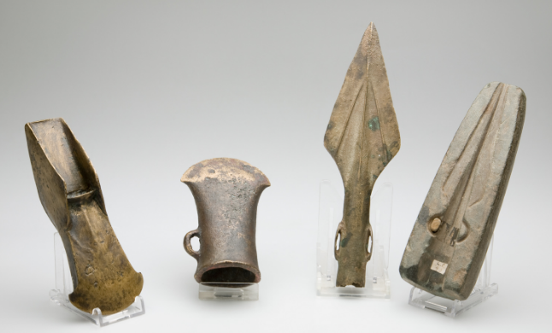
alloy | A metal made by combining two metals. | 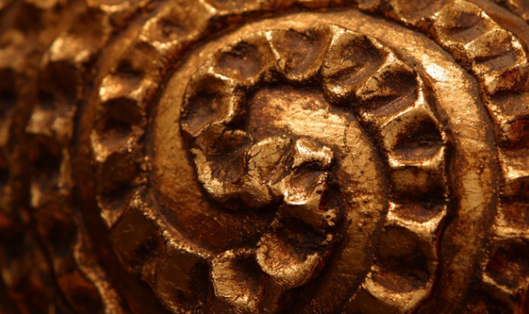
bone  marrow | The substance inside bones, high in fat and a good source of energy. | 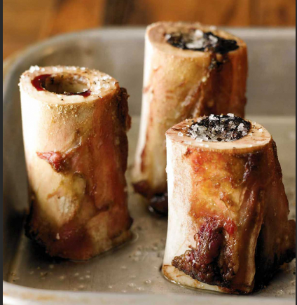
earthwork | A large mound of soil that has been made for a purpose. | 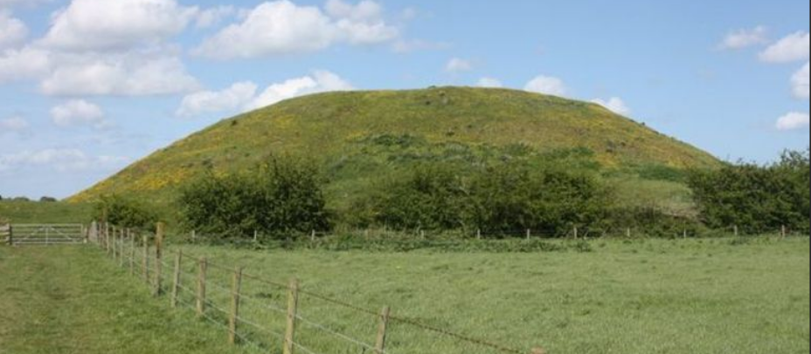
Celt | A modern term for people living in Europe during the Iron Age. | 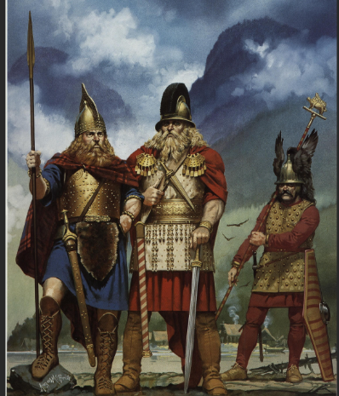
Vocabulary | Definition | Picture
sacrifice | To give something up, break it or kill it as an offering to a god. | 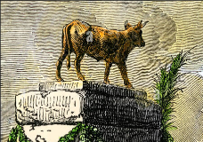
tribe | A group of people, often related through culture with one leader. | 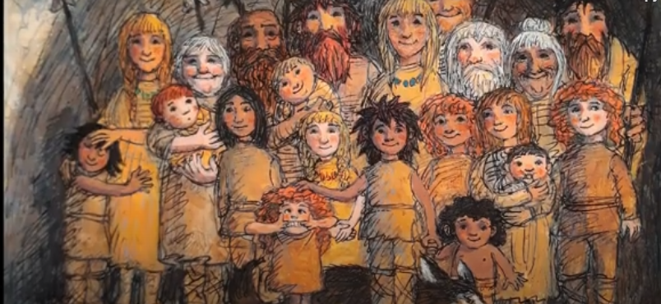
iron | A metal that is stronger and harder than bronze. | 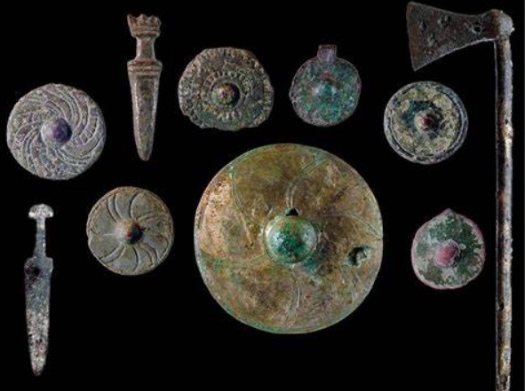
Roundhouses | A circular house with a conical (cone shaped) roof. | 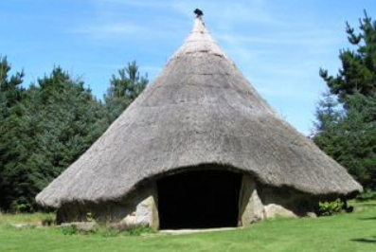
Stonehenge | A pre-historic monument in SE England built in the Stone Age. | 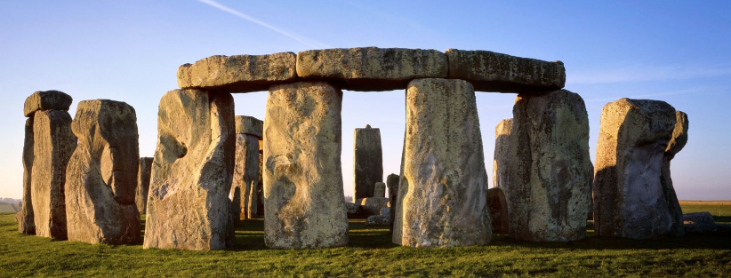

Sticky Knowledge
Chronological understanding
- I know that the Stone Age time period began approximately 6,000 years ago and ended around 2000 BC.
- I know that the Stone Age period came before the Bronze Age.
- I know that BC means before Christ was born
- The Bronze Age was followed by the Iron Age when tools and weapons became more advanced and were used for farming.
- Prehistory can be divided up into 3 time periods – Stone, Bronze and Iron
Historical enquiry
- Our knowledge of the Stone Age people came from cave paintings and fossils.
- The Stone Age falls under prehistory
Historical interpretations
- I know the Stone Age people moved around and didn’t have formal settlements
- I know that Stone Age people drew paintings that told tales of animals in the area
- I know that different sources tell us different stories/information
Understanding of events, people and changes
- I know Bronze Age people melted metal (cast metal) to create materials to hunt
- I know that Bronze Age people formed settlements
- I know that the Stone Age people were hunter-gatherers
- I know that Stone Age people made monuments, like Stonehenge
I know that during the Palaeolithic Age (old stone age), man gathered food by hunting wild animals and birds, fishing, and collecting fruits and nuts.


